

Emergency Preparedness &
Crisis Response Plan

2025-2026



Table of Contents

Mission & Responsibilities……..……………….………………………………………………………………….4
Crisis Team Members 5
Medical Incident/Emergency 6
Code System 6
LOCKDOWN 6
Soft Lockdown………………………………………………...…………………………………………………………6
Hard Lockdown…………………………………………..………………………………………………………………7
Active Shooter/Weapons 8
Hostage 8
Intruder 8
Hostile Person 8
Kidnapping 9
EVACUATION 9
Fire 10
Bomb Threat 10
SHELTER-IN-PLACE 11
Tornado/Severe Weather 11
Hurricane 12
Chemical Spill/Bio Hazard 12
Emergency School Closings 12
Emergency Outside of School 12
Suicide Threat 12
Abuse/Neglect………………………………………………..………………………………………………………..13
Service Areas for Evacuation 13
Evacuation Map 16
Bomb Threat Questionnaire 17
Homicide/Suicide Assessment/Protocol 18
Suicide Severity Rating Scale…………………………………………………………………………………….22

Department of Children & Family Services Report Form……………………………….............25
Incident Reporting Form 30
Crisis Response Procedures Review 31
Operations Plan After Incident 32
Sample Letters 33
Local & State Emergency Numbers 37

MISSION

The Max Charter School acknowledges that effective crisis management begins well before a critical event occurs. Max Charter has therefore established the Emergency Preparedness and Crisis Response Plan to provide the framework and guidelines for handling the immediate action and operations required to respond to an emergency, disaster, or crisis situation. The overall priority of the Max Charter School during such an incident is to protect the life and well-being of its students and staff. The objective of this plan is to respond to emergency conditions and facilitate the process of restoring the school’s academic programs and services.

RESPONSIBILITIES

The following are the responsibilities of the Principal/Designee during a crisis event:
- Verify information.
- Call 911 if an emergency exists.
- Call NSU Police for a situation involving hostile person(s).
- Seal off high-risk areas, if necessary.
- Evacuate students and staff, if necessary.
- Notify staff (and parents where appropriate).
- Convene Crisis Team.
- Notify the Chairman of the Board.
- Keep detailed notes and maintain documentation of an incident.
- In the absence of the Principal, the Business Manager will assume his/her responsibilities, followed by the Data Specialist.

The following are the responsibilities of the Faculty/Staff during a crisis event:
- Barricade classroom doors (unless an evacuation has been ordered).
- Account for all students.
- Keep students calm.
- Take class roster to an evacuation site.
- Take cell phone to evacuation site, if possible.
- Keep detailed notes of an incident.
- Refer media to the Principal/Designee.

CRISIS TEAM MEMBERS

School Committee

NAME/POSITION | DUTY | EVACUATION POSITION
Angelic Rodrigue, Principal | Direct responsibilities/secure premises; set up Command Post | Command Post
Cheryl Theiss,  Administrative Assistant | Secure student information binder/student check out; Secure megaphone | Parent Area
Angie Berthelot,  Business Manager | Secure crisis kit and medications | Medical Area
Matthew Melancon,  Data Specialist | Assist Principal | Command Post

District Committee

NAME | PHONE | POSITION
Jake Giardina | 985-209-3827 | Chairman of the Board
Karen Chauvin | 985-855-3857 | President of the Board
Jason Talbot | 985-448-4946 /  985-438-7204 | Nicholls State

Contact numbers for various local and state agencies can be found at the end of this plan.

MEDICAL INCIDENT

The following response will be initiated in a MEDICAL situation:
- Assess severity level; determine if an emergency exists.
- Call 911 for an emergency.
- Call NSU Police, if necessary.
- Refer to the medical binder for information regarding allergies, conditions, etc.
- Isolate and immobilize the victim, if possible.
- Notify the parent or legal guardian.
- Complete incident form.

CODE SYSTEM

The following code system will be used to guide the response to various emergency events/crisis situations.

Lockdown – Soft (Potential Dangerous Situation) and Hard Lockdown (Active Shooter/Armed Individual, Hostage Situation, Intruder/Hostile Person)

Evacuation (Fire, Explosion, Bomb)

Shelter in Place (Weather, Bio Hazard)

LOCKDOWN PROCEDURES

*Lockdown mandates all personnel lockdown immediately;
The crisis team will not assemble until told to do so*

Soft Lockdown: Threat of a situation is possible but not imminent

General procedures
- Principal/Designee announces “SOFT LOCKDOWN” over PA system.
- Students, faculty, and staff are to remain in their current locations, but teaching and learning may continue.
- Close all blinds.
- Teachers should take roll in order to account for all students.
- If students are out of the classroom, they should return to their teachers immediately.
- Principal/Designee provides information to faculty and staff as appropriate.
- Movement within the building is supervised by the Principal/Designee and limited to emergencies.
- Faculty and staff should wait for the “ALL CLEAR” signal to end the instructional lockdown.

Hard Lockdown: 1. Active Shooter or Armed Individual / 2. Hostage Situation / 3. Intruder / 4. Hostile Person / 5. Kidnapping

General procedures
- Principal/Designee announces “HARD LOCKDOWN” over PA system, thus directing all students, staff, and visitors to immediately follow lockdown procedures.
- If possible: Designated crisis team members check restrooms and halls.
- Contact duty teachers.
- Principal/Designee monitors surveillance video.

Teacher/Staff who spots intruder/situation
- Do not confront the individual.
- Notify office.

Teachers in classrooms
- Secure students from hall into your classrooms.
- Students not with their regular classes (e.g., resource) remain in their current locations.
- Lock/barricade classroom doors; turn off lights; close blinds
- Have students move to the area least visible from the front door and be seated silently.
- Check roll of students.
- Remain quiet and DO NOT ALLOW ANYONE IN OR OUT OF THE CLASSROOM UNTIL THE “ALL CLEAR” IS GIVEN BY PRINCIPAL OR SECURITY PERSONNEL.
- Silence cell phones.
- Display notes to video cameras as needed but remain away for doors/windows.
- Slide colored cards (found in the room’s crisis kit) under the door to signal the level of need for that room (green = no assistance needed; yellow = assistance needed but not an emergency; and red = an emergency within the room is present/immediate assistance is needed). The number of individuals present in the room should be written on the appropriately-colored card.
- Remind students to not use technology.

Cafeteria
- If students are at the tables, have them get underneath the tables facing each other in the tucked position.

In route to and from cafeteria
- Have students seek shelter in the nearest classroom and follow procedures previously stated.
- If there is an incident involving active shooting and students are in range of violence, staff will tell students to lie down, “freeze,” and cover head with hands.

If outside
- Find immediate and nearest shelter; follow evacuation procedures if possible.
- Remain until the “ALL CLEAR” is given (see above).

Crisis Actions

ACTIVE SHOOTER/WEAPONS
- Engage lockdown procedures.
- Notify the Principal/Designee.
- Principal/Designee calls 911 immediately.
- Determine location of intruder.
- If intruder is a MAX Charter School student or if student is found with a weapon, follow disciplinary guidelines and discipline laws.

HOSTAGE SITUATION
- Engage lockdown procedures.
- Notify Principal/Designee.
- Principal/Designee calls 911 immediately.
- Clear the surrounding area immediately.
- Do not allow suspect to gather more hostages by following lockdown procedures.
- Upon arrival of the police, allow them to secure the area and contain the suspect.
- Coordinate with law enforcement in order to set up a command center.
- Assign someone to work in the command that is very familiar with the school, the students, surrounding grounds, etc.
- Allow police to have access to all personnel who may have valuable information about suspect and hostages.
- Notify parents of students being held hostage.
- Be prepared to assist police in an evacuation to a more secure area.

INTRUDERS
- Engage lockdown procedures.
- Principal/Designee calls 911 immediately.
- Give as much information as possible when calling authorities. (e.g., physical appearance, clothing, and location of the intruder).
- If possible seal off any further intrusion.
- Have someone available with the school to assist police.
- Upon arrival of police furnish information to them.

HOSTILE PERSON
- Initiate lockdown procedures.
- Principal/Designee notifies NSU Police.
- Attempt to move the person(s) to an isolated area.
- Move uninvolved students away from the situation.
- Attempt to diffuse the situation by identifying key individuals and concerns.

KIDNAPPING
- Engage lockdown procedures.
- Principal/Designee notifies NSU Police immediately.
- Gather as much information as possible on the victim.
- Notify parent or legal guardian.
- If there are witnesses or persons with information, gather these people to a centralized location in order for police and officials to communicate with them in private.
- If kidnapper is a student at The MAX Charter School, then follow disciplinary guidelines and disciplinary laws.

EVACUATION PROCEDURES

1. Fire / 2. Explosion / 3. Bomb

In the case that the fire alarm is not triggered, the Principal/Designee announces, “EVACUATE” over PA system, thus directing all students, staff, and visitors to follow evacuation procedures.

Procedures
- Principal/Designee issues evacuation to the Soccer Pavilion behind the NSU Married Dorms. (Alternative sites: Peltier Park/Pavillion, NSU Betsy Cheramie Ayo Hall, and Babington Hall).
- Principal/Designee calls 911 and/or NSU Police.
- Crisis team convenes at the evacuation site.
- Students and staff follow fire procedures and routes to evacuate the building (see map).
- Children walk to the designated area; team member or first teacher to reach intersection will act as crossing guard, if necessary.
- Maps should be posted in all classrooms indicating primary and secondary routes and holding areas.
- Crisis Team ensures all students are out of the building, including bathrooms/halls.
- Business Manager places an evacuation sign on the front door, if possible, and secures all entrances to the building after team members report that all students and staff are safe until first responders arrive.
- Crisis team members take evacuation supplies to relocation site.
- Principal/Designee notifies the Chairman of the Board.

Teacher Duties For Evacuation
- Follow fire drill procedures unless Principal/Designee alters procedures.
- Take class roster and buddy roster to relocation center.
- Close classroom doors and turn off lights.
- When outside the building, account for all students. Inform Principal/Designee or a crisis team member immediately if students are missing.
- When evacuating, students walk in a line, and teachers flank the line and observe surroundings.
AT the SITE:
- Sit students in designated area.
- Call roll and account for all students.
- Wait for instructions.
- When and where directed, dismiss students according to parent pick-up procedures.

Crisis Actions

FIRE PROCEDURES
- Principal/Designee calls 911 and NSU Police.
- Evacuate the building and have teachers close classroom doors as they are leading their students to the designated area outside. Teachers are to take a head count once outside the building.
- Use designated faculty members as hall monitors to check hallways, restroom, and storage areas to ensure area is cleared of all individuals.
- Keep anyone from reentering the building before the all clear is sounded.
- A representative will meet the fire department at the location agreed upon. This person should have an accurate head count as soon as possible.
- Have someone available who know the entire layout of the building to meet with the fire department officials.
- Keep all driveways clear for emergency vehicles.

BOMB THREAT
- Inform all students, teachers, faculty, staff: DO NOT USE CELL PHONES.
- Principal/Designee notifies NSU Police immediately.
- Evacuate the building immediately through the use of FIRE DRILL procedures.
- Get as much information from the caller as possible and attempt to record his/her statements.
- Attempt to trace the call.
- Attempt to ask the following questions:
- When is the bomb going to explode?
- Where is it right now?
- What does it look like?
- What kind of bomb is it?
- What will cause it to explode?
- Did you place the bomb?
- Why?
- What is your address?
- What is your name?
- Complete Bomb Threat Questionnaire (See Appendix).
- Upon arrival of law enforcement, allow them to secure the area.
- Furnish as much information as possible to police regarding the caller, the building, and surrounding area.
- Have crisis team members available to assist law officials.

SHELTER-IN-PLACE

1. Tornado/Weather / 2. Chemical Spill / 3. Hazardous Materials / 4. Bio Hazard

General Procedures
- Teachers close doors, windows, and turn off air conditioner.
- The Principal/Designee secures outer perimeter doors and windows.
- Notify parents if an evacuation is ordered.

Teachers in classrooms
- Keep all students in classroom.
- Disregard all bells.
- Scan classroom for any unusual objects.
- Wait for instructions.

Crisis Actions

SEVERE WEATHER/TORNADO WATCH
- If a tornado watch has been issued in an area near school, monitor Emergency Alert Stations, National Weather Service, or Weather Channel.
- Take all persons inside the building.
- Close windows and blinds.
- Review tornado drill procedures and location of safe areas. Tornado safe areas are under desks and in hallways away from windows and large rooms.
- Review “drop and tuck” procedures with students.
NOTE: If safety and time permit, the Principal/Designee may evacuate students to a more substantial structure at NSU.

TORNADO WARNING
If a tornado warning has been issued in an area near school or a tornado has been spotted near school:
- Move students to safe areas under desks and in hallways away from windows and large rooms.
- Teachers take roll/account for all students.
- Restrict movement inside the building.
- Ensure students are in the “tucked” position and remain calm.
- Remain in safe area until warning expires or until emergency personnel have issued an all-clear signal.

HURRICANES
- Once a hurricane is noted in the area, follow the instructions on the radio or television designated by officials.
- The Principal/Designee will confer with the Chairman of the Board about school closing.

CHEMICAL SPILLS, HAZARDOUS MATERIALS, & BIO HAZARD
- Principal announces, “Shelter-in-Place.”
- If advised, all should cover mouth and nose with handkerchief, cloth, paper towel, or tissues.
- All persons must remain in safe areas until notified by Principal or emergency responders after law enforcement issues an “All Clear.”
- When HAZ-MAT or DEQ calls about fumes in the area, ask the following:
How long before fumes are at the school?
How long will we be sheltered?
Will we need to evacuate and where?
- If students will be sheltered beyond the school day, food will be made available.

EMERGENCY CLOSING OF SCHOOLS
Employees should listen to the radio and/or watch TV for information concerning reporting to work.

EMERGENCY OUTSIDE OF SCHOOL
Staff will use the phone tree to relay information provided by the Principal.

SUICIDE THREAT

The following response will be initiated if a student threatens to harm himself:
- ALL threats are to be taken seriously.
- Move the student to a private area.
- Do not leave the student unattended.
- Calm the student.
- Consult Suicide Threat file to determine if this is the first occurrence.
- Conduct the Suicide Threat Assessment (C-SSRS).
- Call the parent/guardian.
- Make an appropriate referral (as determined by the threat assessment).
- If the student is not at school when the threat is made known, contact the parent(s) immediately, as well as Law enforcement to conduct a wellness check.
- Document contacts; file incident forms (these must be kept in a secure file in the principal’s office away from general access).

ABUSE & NEGLECT

In accordance with mandated reporting laws, the following response will be initiated if abuse or neglect of a student is suspected:
- Notify the Principal.
- In the presence of the principal, the faculty or staff member who has knowledge of the abuse or neglect makes an official report to the Department of Children & Family Services (1-855-4LA-KIDS).
- Submit the Written Report Form to the Department of Children & Family Services (see page 10).
- NOTE: All faculty and staff are considered “mandated reporters.”

“Abuse” means any of the following acts which seriously endanger the physical, mental or emotional health and safety of the child, including the following:
- The infliction, attempted infliction, or as a result of inadequate supervision, the allowance of the infliction or attempted infliction of physical or mental injury upon the child by a parent or other person.
- The exploitation or overwork of a child by a parent or any other person.
- The involvement of the child in any sexual act with a parent or any other person, or the aiding or toleration by the parent or any other person of the child’s sexual involvement with another person or of the child’s involvement in pornographic displays, or any other involvement of a child in sexual activity constituting a crime under the laws of this state.
- The coercion of a child into having an abortion.

“Neglect” means the refusal or unreasonable failure of a parent or caretaker to supply the child with necessary food, clothing, shelter, care, treatment, or counseling for injury, illness, or condition of the child, as a result of which the child’s physical, mental, or emotional health and safety is substantially threatened or impaired.

SERVICE AREAS for EVACUATION

COMMAND POST

At the direction of the Principal/Designee, the Administrative Assistant communicates with outside medical and official personnel and relays information where necessary; maintain documentation

WHO:
- Principal/Designee to monitor requests from parents or medical triage area.
- Data Specialist (floats to other areas as needed).

WHERE: At command post location (on or off campus)

MEDICAL AREA

WHO:
- CPR/first aid trained personnel
- Business Manager as recorder

WHAT: Blanket, first aid supplies, gloves, water, pen and paper, markers, name tag

WHERE: Work with law enforcement, EMS and custodian on locations for EMS arrival

DUTIES
- Assist injured until EMS arrives
- Identify injured persons
- Record names and hospital locations (write last name with marker upper arm of students or other area)
- Send names of injured and hospital location to command post via walkie-talkies

PARENT AREA TYPE I
- Student Release-on campus or at an alternative evacuation site.
- Verify student name for release.
- Parents are designated on campus or at an alternate evacuation site.
- Law enforcement will assist with crowd control.

WHO: Law enforcement, staff, Administrative Assistant

WHAT: Megaphone, list of students and staff, release forms

DUTIES: Maintain a list of students released to parents.

PARENT AREA TYPE II

Parent area during search and rescue; usually located at alternate evacuation site off campus.

WHO: 2 crisis team members, volunteers, clergy, counselor, mental health professionals

WHAT: Blankets, coffee, food, water, walkie-talkie, pens, paper, name tags, permanent markers, books or games.

DUTIES
- Comfort parents.
- Restrict areas.
- Record names of parents and children involved in the incident, as well as staff members.
- Transfer information to command post or medical triage area.
- Provide parents or staff members’ families with updated information on the rescue effort
- Inform parents or staff members’ families when loved one has been found and hospital locations.
- Utilize volunteers for activities with younger children and to serve food.

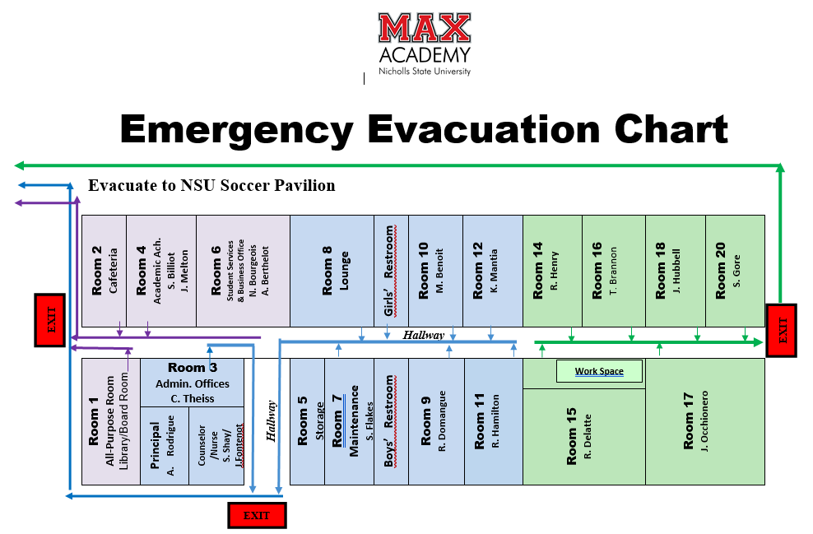
Bomb Threat Questionnaire

Time: _______________ Date:______________

Sex of caller ______ Race_____ Age____ Length of call _________

Number from which call was received_____________________
Exact Wording of the Threat:
________________________________________________________________________________________________________________________________________________________________________________________________________________________

Caller’s Voice:
___calm ____angry ___excited ___laughter
___slow ___rapid ___slurred ___whisper
___soft ___crying ___normal ___distinct
___loud ___nasal ___ragged ___disguised
___deep ___raspy ___stutter ___ cracking
___lisp ___accent ___familiar ___ deep breathing

*If voice is familiar, who did it sound like?_________________________________

Background Sounds:
___clear ___voices
___street noises ___ house noises
___animal noises ___ PA system
___machinery ___ echoes
___ other

Threat Language:
___foul ___taped ___well spoken
___irrational ___incoherent
___message read by threat maker______________

Insert Risk/Threat/Lethality Assessment Here

Max Charter SCHOOL

Self-Injurious Behavior Risk Determination and Procedures
DATE:

STUDENT’S NAME:_______________________________________AGE:_______ DOB: _________

SCHOOL: _________________________________________________SCHOOL CODE #: _________

STUDENT ID #: __________________________________GRADE: _____________SEX:__________

STUDENT HAS PRIOR HISTORY OF THREATS: YES_____NO_____If yes, number of TV_____and/or number of SI________

Educational Disability Status: Section 504 Special Education _____ Non-Disabled _______
**************************************************************************************
______ LOW RISK (Five of the below criteria indicated should be met---Check all that are appropriate)
______Communication of some morbid or self-destructive ______No explicit threat / lacks detail
ideation was made, but student denies need for concern. ______Appropriate emotional reaction to current life stressor
______Can define support systems and access to resources. ______Can give reasons for not dying, and for remaining involved in life without ambivalence
______Thoughts of suicide without intent
______Threat is reactive and can be connected to a precipitating ______Can identify an adult at the school to communicate
event concerns to in the future if the need arises.
____________________________________
Responsible Personnel (Signature Required): Name of adult at school

Interviewed student and made risk assessment.
Notified Pupil Appraisal Personnel, if necessary.
Notified parent and obtained signature documenting notification
___________________________ Advised parent to seek community-based counseling from a licensed
mental health professional.
**************************************************************************************
______ MODERATE RISK (Three or more of the below criteria indicated should be met--Check all that are appropriate)

______Communication of some morbid or self-destructive ______Mild/Moderate behavioral changes
ideation was made, but no definite plan/means ______More than one referral for threats
______History of self-injurious attempts ______Self-injurious behaviors without associated morbid
______Mild/Moderate depression/mood swings threats or ideation
______Report of previous suicidal ideation ______Recent rejection, loss, disappointment possibly related to
______Victim of physically or verbally abusive peers (e.g., being bullied) underlying threat
______Recent life stressor deemed as significant

Responsible Personnel (Signature Required):
Interviewed student and made risk assessment.

Contacted Pupil Appraisal Personnel for second assessment, if deemed necessary

Requested that parent come to school for conference and sign notification letter documenting need for assessment.
Advised parent to seek outside assessment from community-based mental health facility if deemed necessary
Followed-up with appropriate agencies if non-compliance becomes a factor
**************************************************************************************
______ HIGH RISK (Three or more of the below criteria indicated should be met-- Check all that are appropriate)

- Communication of some morbid or self-destructive ideation was made | - Suicide pacts | - History of suicide in family/friends
- History of attempts | - Significant depression | - High risk taker
- Helpless or hopeless orientation or outlook | - Significantly withdrawn or isolated | - Self-injurious behaviors with associated morbid ideation or threats (e.g., cutting, carving)
- Major behaviors/mood changes | - Recent crisis in life | - History of abuse or neglect
- Identifies specific plan and/or means** | - Numerous unexcused absences | - Threats suggests concrete steps have been taken towards carrying out the threat**
- Serious history of loss, rejection, disappointment possibly related to underlying threat | - High likelihood of use of drugs/ alcohol (including intoxication at school) | - Victim of physically or verbally abusive peers (e.g., being bullied)
- Recent life stressor deemed as severe | - Emotional pain feels unbearable | - Few, if any, resources

**This indicator may be sufficient itself without more.

Responsible Personnel (Signature Required):

Remained with or saw that student was not left unattended.

Interviewed student and made risk assessment.

Requested Pupil Appraisal Personnel be present if necessary.

1. Requested that parent come immediately.
2. Attempted to refer by telephone in the presence of the parent(s) a community-based mental health facility of their choice.
3. Secured signature on parent notification sheet
______________________________ Followed-up with appropriate agencies if non-compliance becomes a factor.
**************************************************************************************
For all Risk Determinations: For students excluded from school for threat:
1 Sent copies of forms to School Administrator, 1. An administrators conference to review recommendations made by community
based mental health agency
l 2. Development of a School Safety Plan
**************************************************************************************
SI-1 Rev. 1/10 Please Put Copy in Cumulative Folder

Max Charter School

Threat of Violence Risk Determination and Procedures
DATE:

STUDENT’S NAME:_____________________________________ AGE: DOB:
SCHOOL: SCHOOL CODE #:

STUDENT ID #: ____________________________________GRADE: SEX:
STUDENT HAS PRIOR HISTORY OF THREATS: YES NO If yes, number of TV and/or number of SI

Educational Disability Status: Section 504 Special Education Non-Disabled
**********************************************************************************
LOW RISK (Five of the below criteria indicated should be met---Check all that are appropriate)

______Made threat/implication of violence ______No means or access to weapon(s) to carry out threat
______Admits to and expresses true sense of remorse. ______Threat is vague and unspecific
______Accepts responsibility for threat ______Good support network of friends and family
______Threat is “reactive” and can be connected to a ______Can identify an adult at the school to communicate concerns
precipitating event ____________________ to in the future if the need arises.
__________________________ , Name of Adult at School

Responsible Personnel (Signature Required)
Interviewed student and made risk assessment.

Notified Pupil Appraisal Personnel, if necessary.

Notified parent and obtaining signature documenting notification, if deemed necessary.
**********************************************************************************
MODERATE RISK (Three or more of the below criteria indicated should be met--Check all that are appropriate)

________Made threat/implication of violence Somewhat self-critical/pessimistic outlook
________History of any incident of property Recent rejection, loss, or disappointment possibly
destruction, fighting, theft related to underlying threat
Possible availability of weapons
Some exposure to use of weapons Tendency to excuse behavior
Small network of friends / socially withdrawn Threat is more direct, detailed and concrete than
low-level threat
No clear indication that concrete steps have Victim of physical or verbal abuse by peers (e.g.,
been taken to carry out threat being bullied)

Responsible Personnel (Signature Required):

Interviewed student and made risk assessment.
Contacted Pupil Appraisal Personnel for second assessment, if deemed necessary.
Requested that parent come to school for conference and sign notification letter documenting need for assessment.
Advised parent to seek outside assessment from community-based mental health agency, if deemed necessary
**********************************************************************************
HIGH RISK (Four or more of the below criteria indicated should be met--Check all that are appropriate)

Made threat/implication of violence Refusal to retract threat
Previous involvement in deceptive activity, History of violence by student
(e.g., theft, forgery, sabotage of authority) Little to no sense of consequences
________Numerous unexcused absences History of suicidal behavior
________Excuses and justifies threat History of explosive outbursts
________Exhibition of racist or supremacist view Isolated friendships, especially fringe or delinquent characters
________History of fire-setting or cruelty to animals History of probation/criminal activity
________High interest in and knowledge of guns, bombs, Dwelling on previous or notorious events, threats
knives, or other destructive weapons either or similar circumstances (personal or public)
communicated verbally, in writing or through Serious history of loss, rejection, or
the use of a computer, cell phone, or any other depiction disappointment possibly related to
underlying threat
Embroiled in and/or representative of gang/turf/ High likelihood of use of drugs/alcohol
neighborhood or kinship conflicts History of being abused or neglected
History of mental health treatment _______ Threat suggests concrete steps have been taken
towards carrying out the threat**
Victim of physical or verbal abuse by peers
(e.g., being bullied) Threat is direct, specific and plausible**
**This indicator may be sufficient itself without more.
Responsible Personnel (Signature Required):

Remained with or saw that student was not left unattended.

Interviewed student and made risk assessment.

Requested Pupil Appraisal Personnel and/or legal authorities be present.

1. Requested that parent come immediately.
2. Secured signature on parent notification form.

Advised parent to seek outside assessment from community-based mental health agency.
**********************************************************************************
For all Risk Determinations: For students excluded from school for threat:
1. Sent copies of forms to Administration 1. An administrator’s conference to review
recommendations made by community-based
2. Sent copies of forms to Parent mental health agency.
2. Development of a School Safety Plan
.
TV-1 Rev. 1-10 Please Put Copy In Cum. Folder

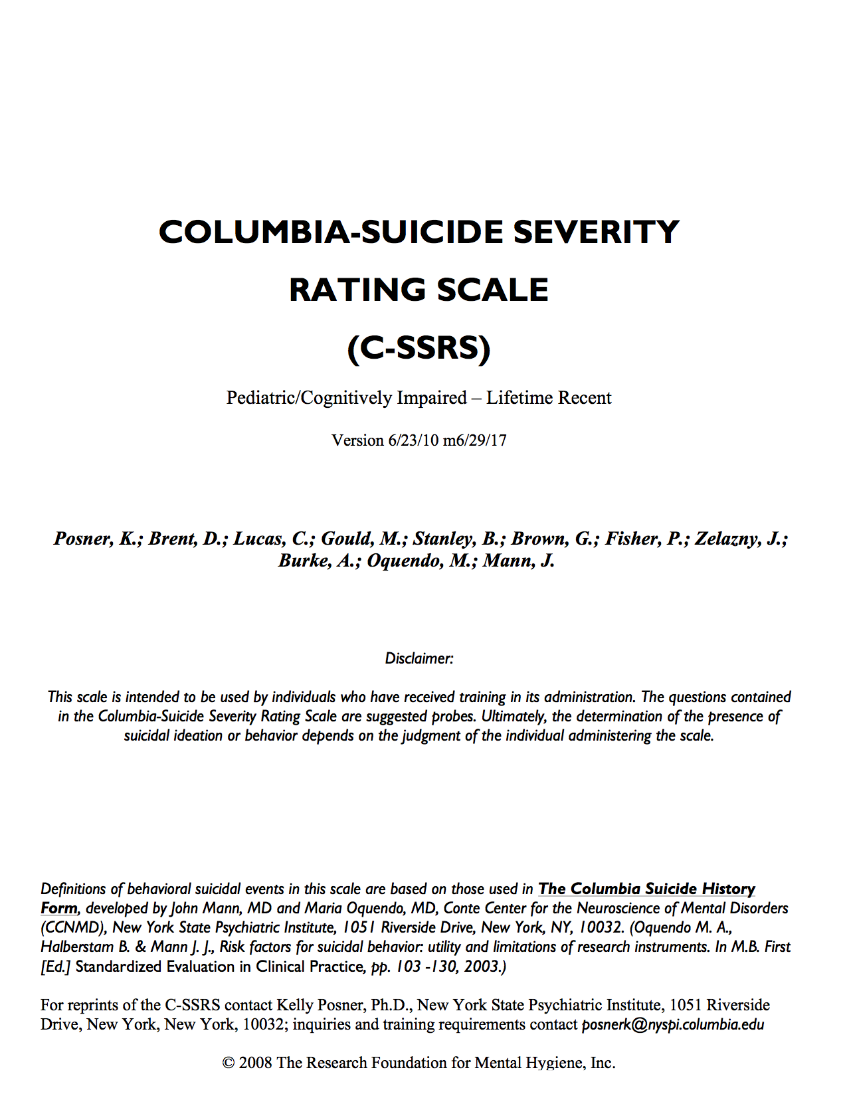
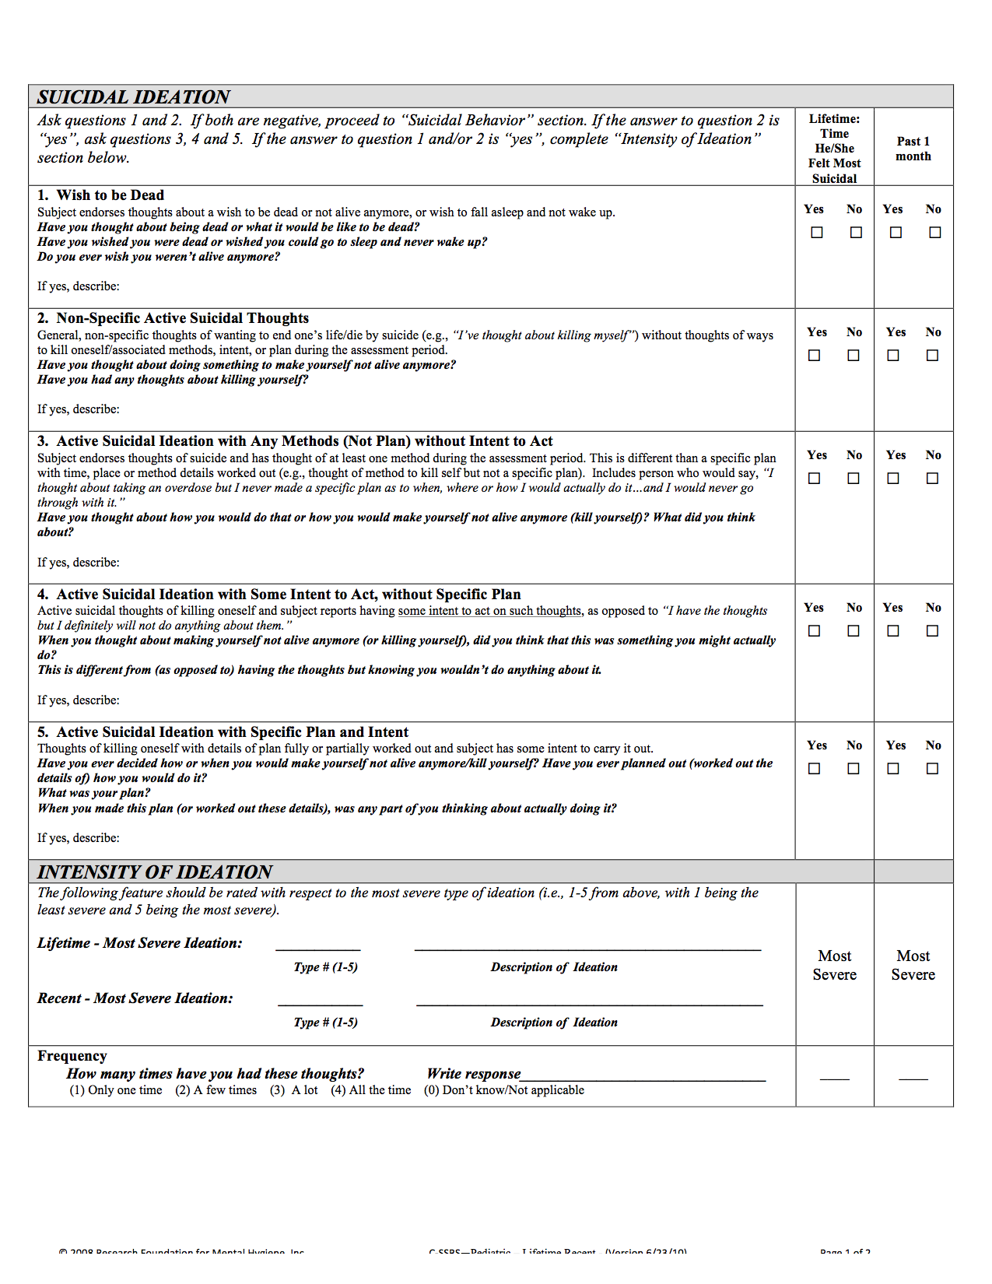
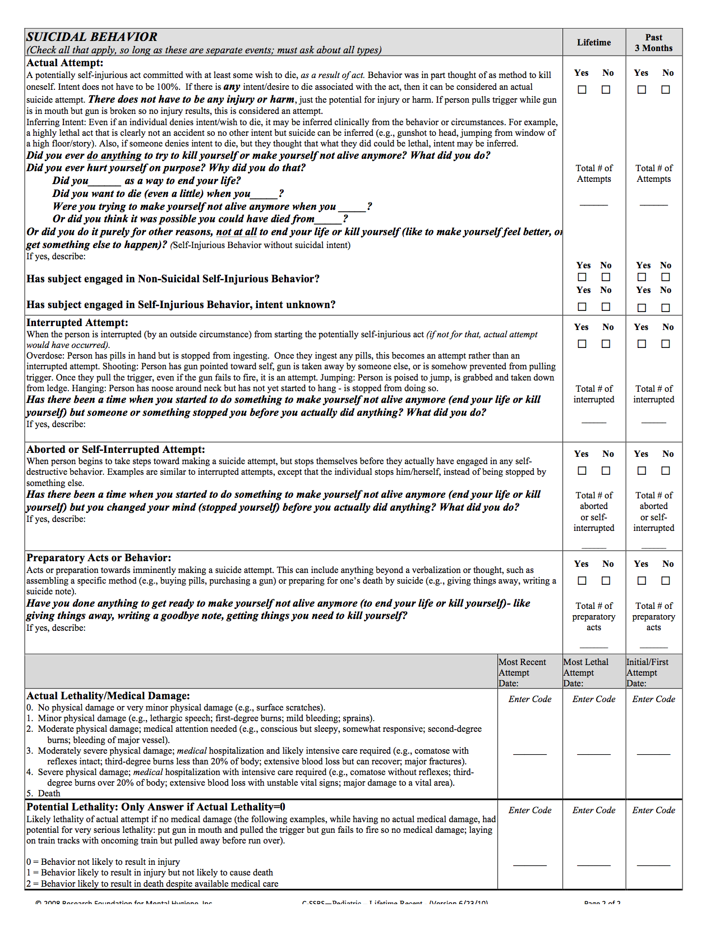
a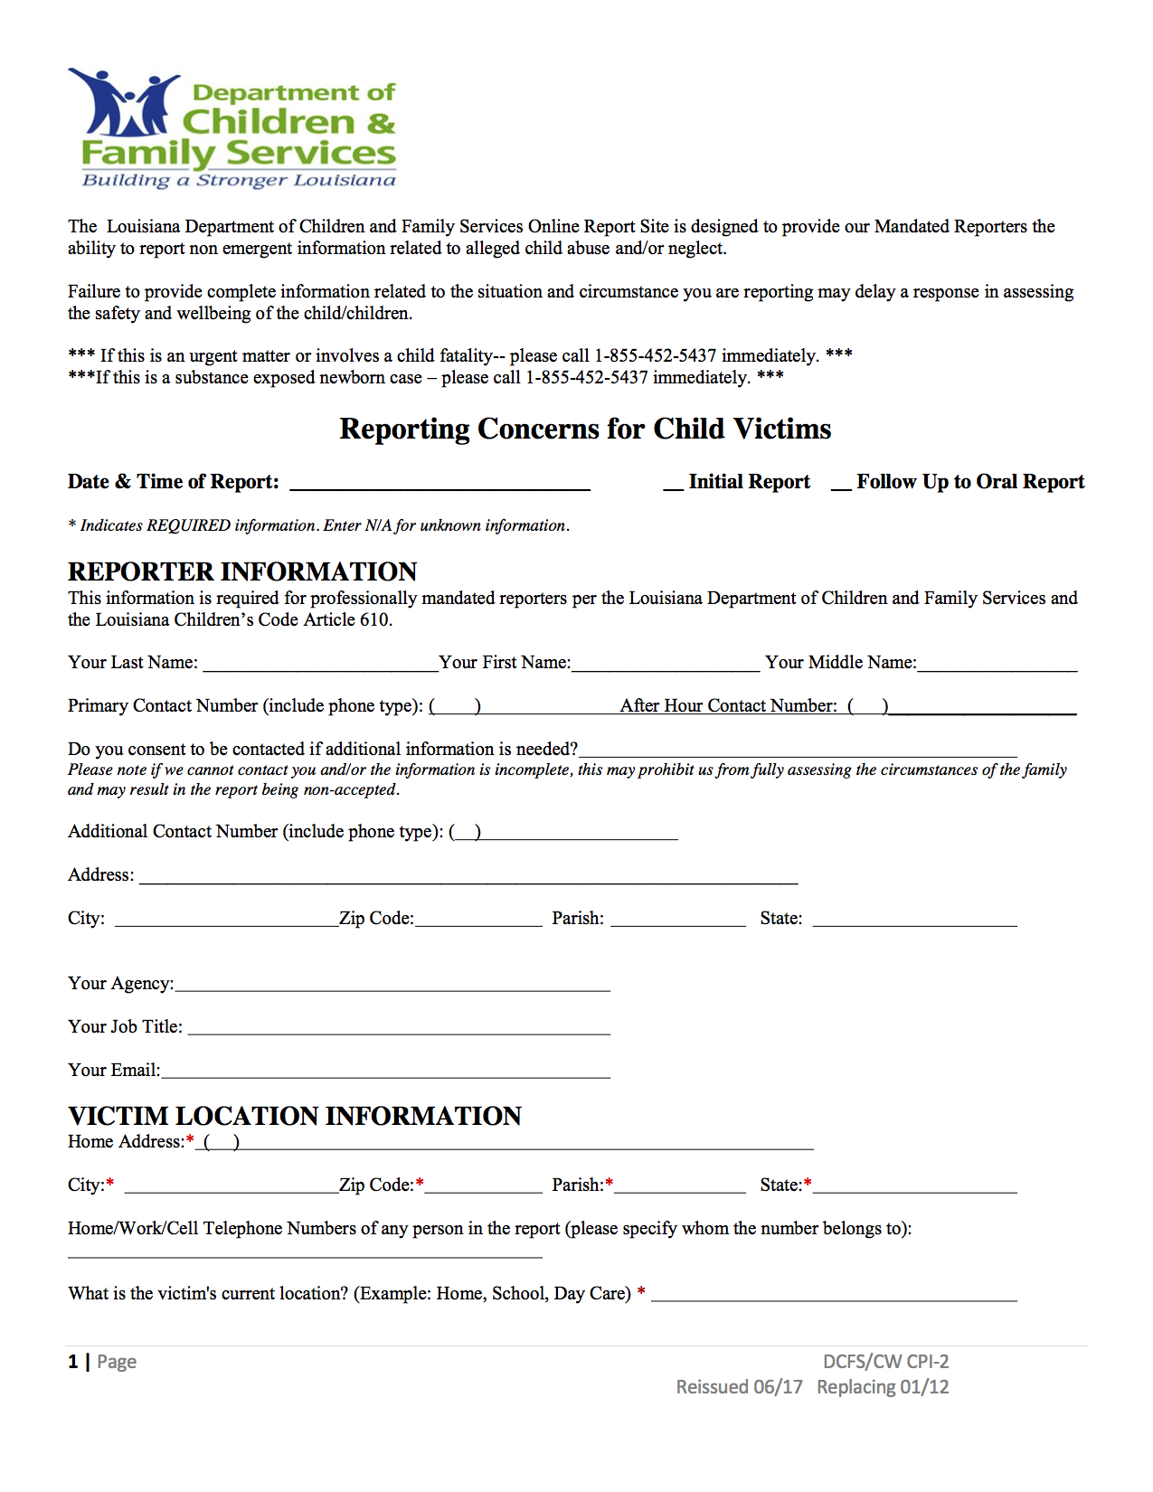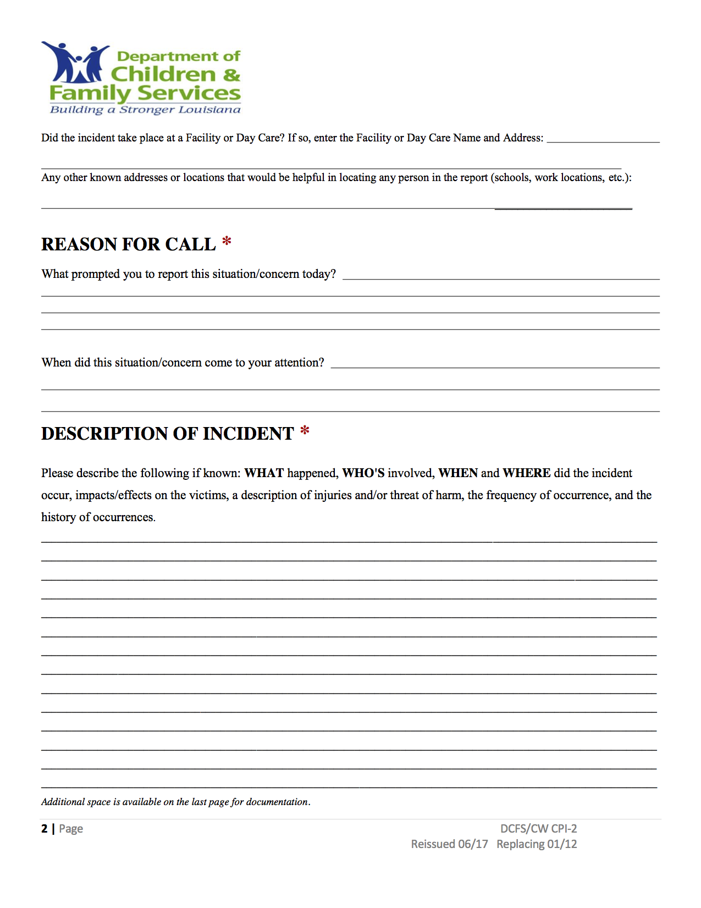
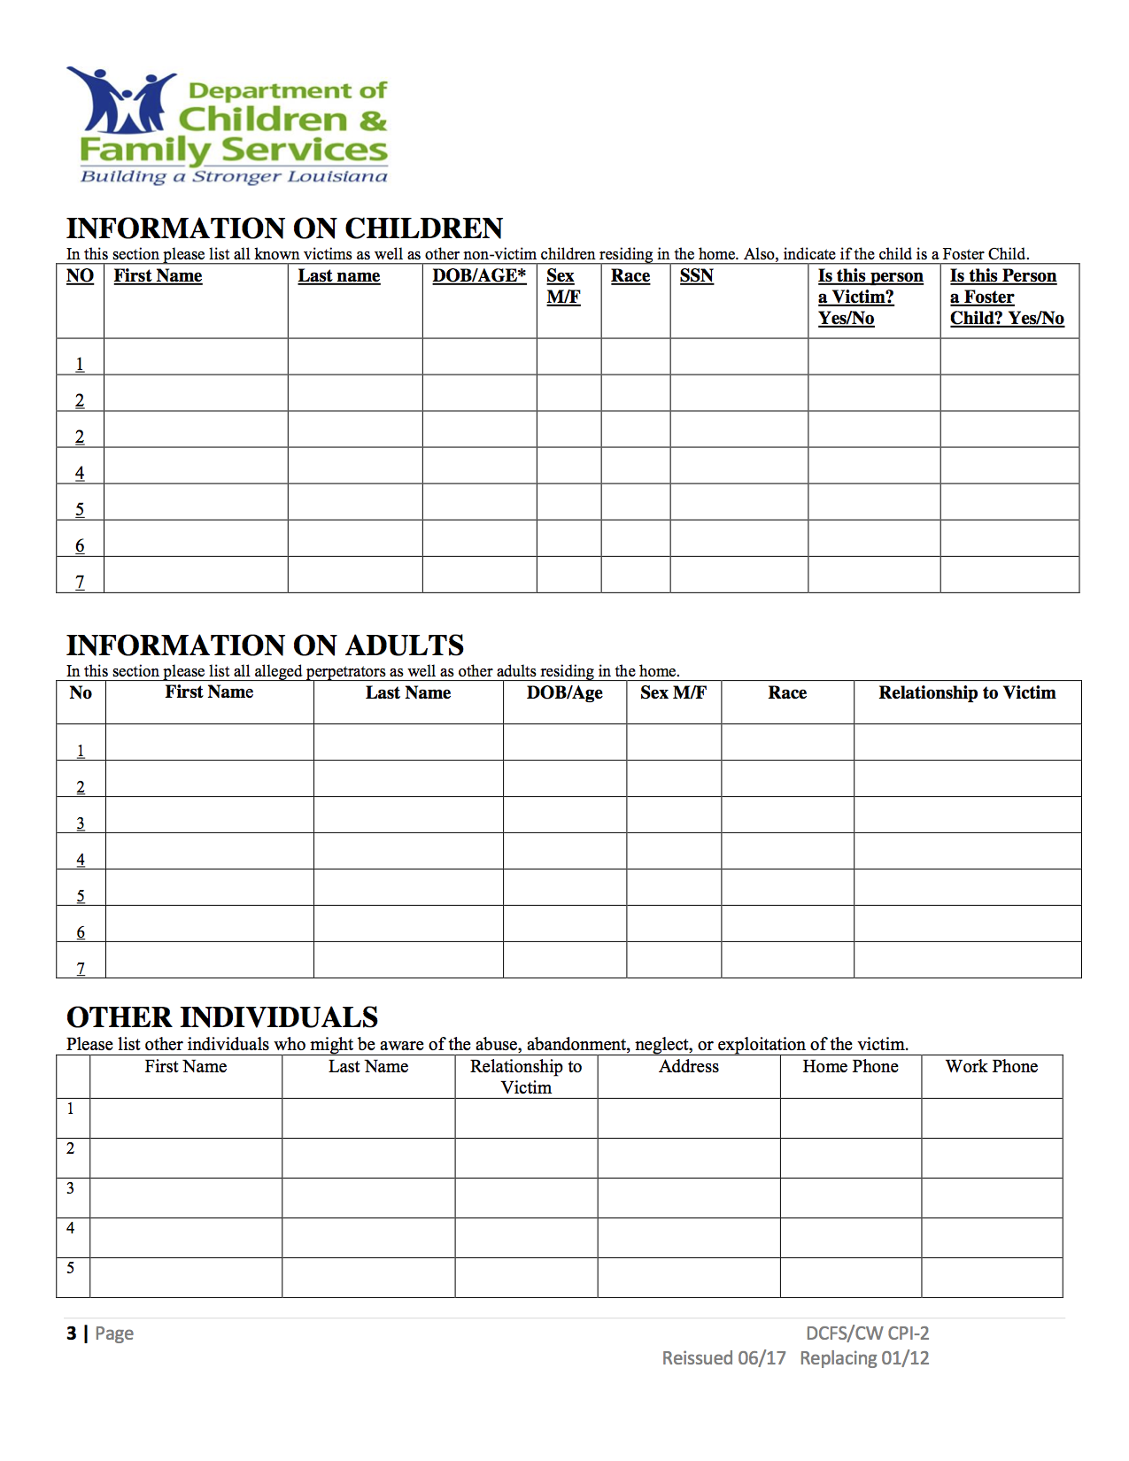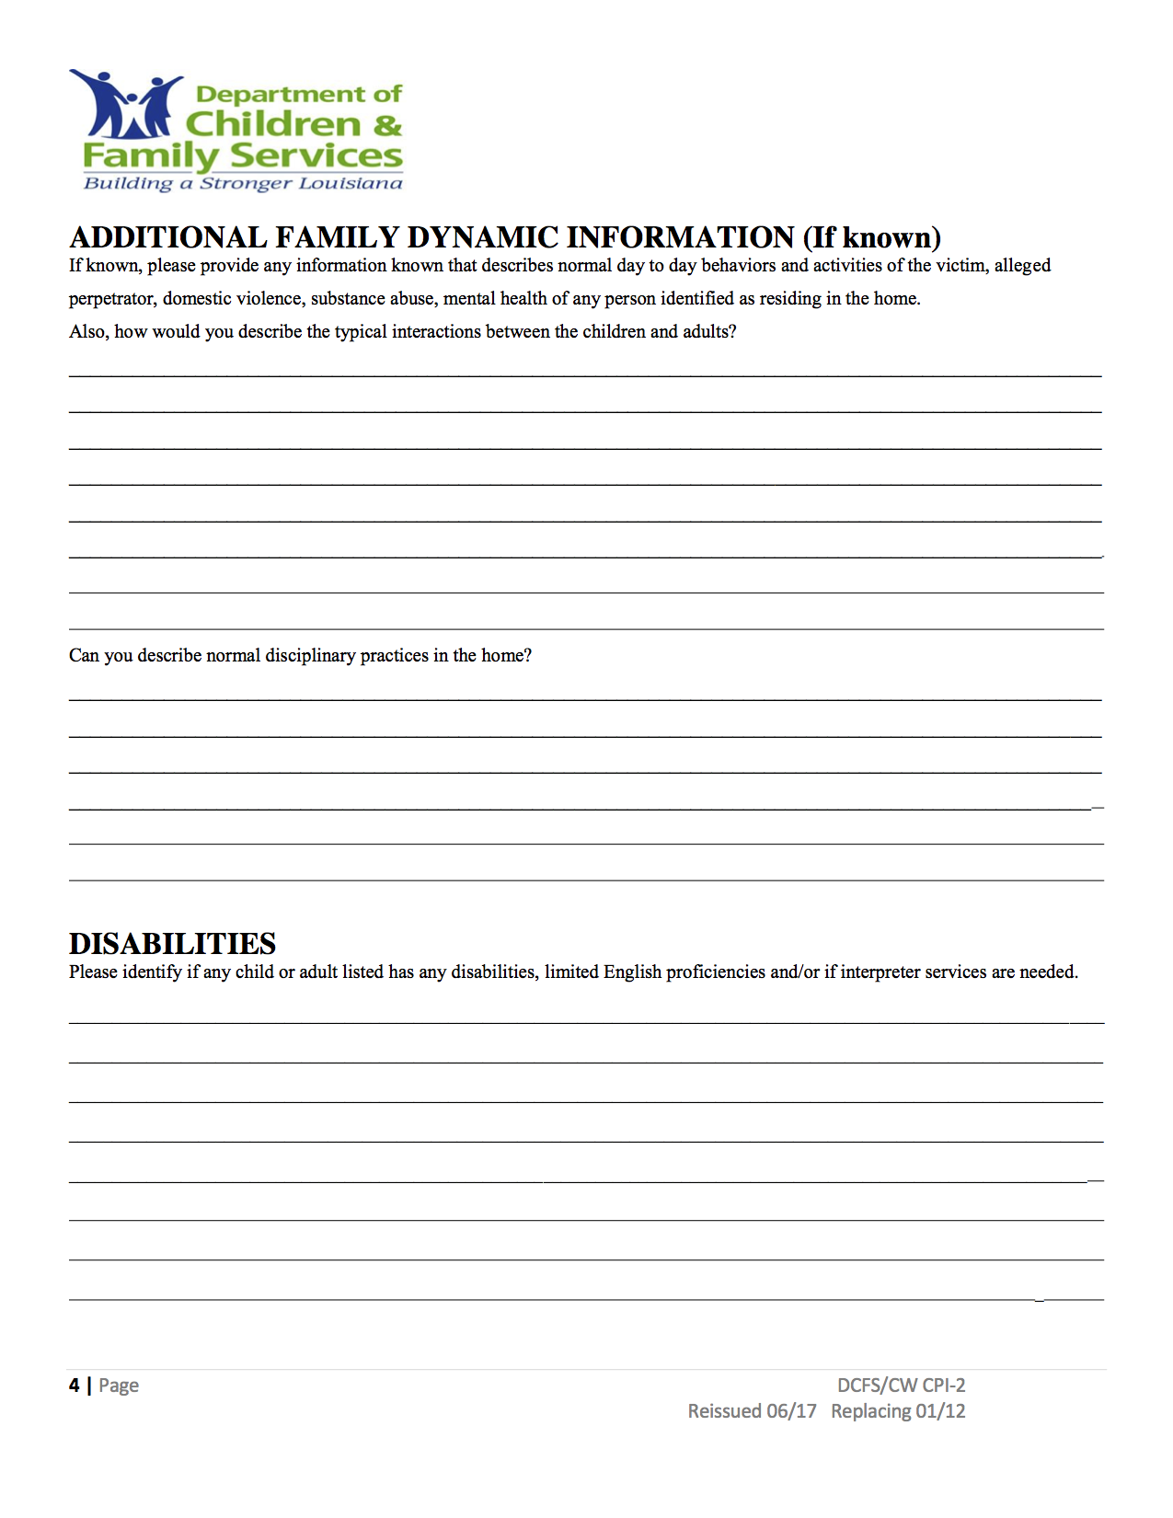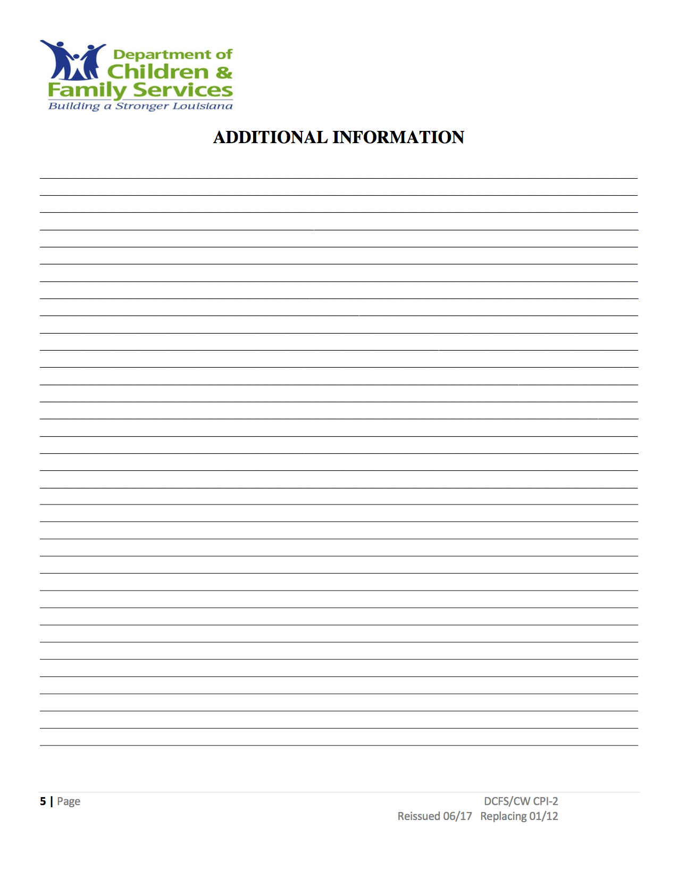

INCIDENT REPORTING FORM

DATE:
SCHOOL REPORTING:
WHAT HAPPENDED/KIND OF CRISIS
INCIDENT:

WHO RESPONDED:

TIME OF INCIDENT:

TIME INCIDENT ENDED:

COMMENTS:

SIGNATURE OF PERSON FILLING OUT FORM

CRISIS RESPONSE PROCEDURES REVIEW

School: MAX Charter
Date Reviewed:

- Type of Crisis:

- Briefly describe the crisis situation:

- What crisis response procedures were most effective? What worked well?

- What procedures need to be improved /modified or changed?

- Any other comments:

Crisis Team Members participating in review:

MAX Charter
Operational Plan

Operation Plan for the 1st week after the Crisis Incident: The school will follow the prepared plan for the daily schedule until it is able to operate in the normal capacity of a school day.

- Students morning drop off time:
- School will begin at:
- Instructional times:

- Recess times will be:
- Lunch time and Schedule of classes:

6. Dismissal location and times are:

MAX Charter School
100 Afton Drive
Thibodaux, LA 70301
Phone: 985-227-9500 Fax: 985-227-9515

Date:_______________

Dear Parents,

We will be conducting our tornado, fire, and school safety drills periodically throughout the school year. We have our Crisis Response Plan in place and need to practice these procedures for the protection and safety of your child and school staff. We will also practice an evacuation drill to our evacuation sites. You will be notified in advance if we will have the evacuation drill off campus.

If you have any questions or concerns, please contact me. Thank you for your cooperation.

Sincerely,

Principal

MAX Charter School
100 Afton Drive
Thibodaux, LA 70301
Phone: 985-227-9500 Fax: 985-227-9515

Date:______________

Dear Parents,

This letter is coming to you in light of the recent crisis incident at MAX Charter School. School for your child will resume on ____________. We will follow the normal schedule for a school day. We have reviewed the crisis incident and have found everything concerning the incident to be taken care of by the proper authorities. We appreciate your cooperation and assistance to make sure your child stayed safe and was able to be returned to you as quickly as possible.

If you have any special concerns for you or your child you would like to have addressed or discussed, please fill out this form and return it to the office.

Name of Student:____________________________
Name of Parent:_____________________________
Phone number where parent can be reached:_______
Area of concern you would like to address and discuss:____________________________________

MAX Charter School
100 Afton Drive
Thibodaux, LA 70301
Phone: 985-227-9500 Fax: 985-227-9515

Date: ______________

Dear Parents,
Due to the recent incident at the MAX Charter School, we will have mental health professionals at our school on the dates and times listed below. If you feel your child needs to speak with a professional, please check the appropriate date and time listed at the bottom and return to school by ________________. Students may also be referred by teachers or school staff, or students may self-refer.

________Yes, I would like for a professional to speak with my child due to ___________.

Child’s Name: _____________________________
Parent’s Signature: _________________________

Check a Time | Dates | Time

LOCAL AGENCIES
AGENCY | PHONE NUMBER
Nicholls State University Police | 985-448-4911 or 985-448-4746
Fire | 911
Utilities | Entergy: 800-368-3749  Phone/Cable: Charter – 877-728-3814  Sewerage/Water – City of Thibodaux – 985-446-7223
NSU Office of Environmental Health and Safety | 985-448-4783
Radio Stations | KCIL – 985-448-1075/851-1026  KTIB – 985-447-6404
Television Stations | Fox 8 – 504-486-6161  WWL Channel 4 – 504-529-6398
Newspapers | Daily Comet
Hospitals | Thibodaux Regional Medical Center  985-447-5500
EMS | Acadian Ambulance/Air Med  800-259-2222
Health Unit--Lafourche Parish-Thibodaux | 985-447-0921
Thibodaux Police Department  Lafourche Parish Sheriff’s Office | 985-446-5021  985-448-2111
Social Services | 985-447-0945
OEP (Office of Emergency Preparedness) | 985-446-8427

STATE AGENCIES
Helpline for Emergencies | 225-342-6600
Rape Crisis Hotline | 800-656-4673
Suicide Prevention | 225-226-2273
Child Abuse/Neglect Reporting Line | 1-855-452-5437
Runaway Hotline | 800-621-4000
National Center for Missing/Exploited Children | 800-843-5678
Crime Victims Bureau | 888-342-6110
Domestic Violence | 800-799-7233
Hazardous Materials/Poison | NSU 985-448-4783
Hazardous materials leak or spill | 877-925-6595
Poison Control Center | 800-256-9822
American Red Cross | 225-291-4533
Emergency Management Agencies | 985-447-3229
Office of Emergency Preparedness | 800-256-7036
Chemical Emergency Response | NSU 985-448-4783
Bio Terrorism Response | NSU 985-448-4783
Radiological Response | NSU 985-448-4783

